Celebal Summer Internship 2026
Spark Assignment:
Q1: Explain the roles of the Driver, Cluster Manager, and Executor in a Spark application.
Driver
- The main process of a Spark application.
- Creates the SparkSession/SparkContext.
- Converts user code into execution plans (DAG).
- Schedules tasks and sends them to executors.
- Collects results from executors.
Cluster Manager
- Manages cluster resources.
- Allocates CPU and memory to Spark applications.
- Examples:
  - Standalone Cluster Manager
  - YARN
  - Kubernetes
  - Mesos
Executor
- Worker processes running on cluster nodes.
- Execute tasks assigned by the Driver.
- Store cached data in memory.
- Return computation results to the Driver.
Flow:
Driver → Cluster Manager → Executors → Results back to Driver

Q2: How does Spark’s Lazy Evaluation strategy improve performance when chain-processing large datasets?
Spark does not execute transformations immediately.
Instead, it:
- Records transformations in a DAG (Directed Acyclic Graph).
- Waits until an Action is called.
- Optimizes the entire execution plan before running it.
No computation occurs until an action such as:
df.show()
Benefits
- Reduces unnecessary computations.
- Optimizes execution plan.
- Minimizes disk I/O.
- Improves performance on large datasets.

Q3: Write a Spark command to read a CSV file located at "data/source.csv", ensuring the first row is treated as a header and inferSchema is enabled.
df = spark.read.csv(
"data/source.csv",
header=True,
inferSchema=True
)
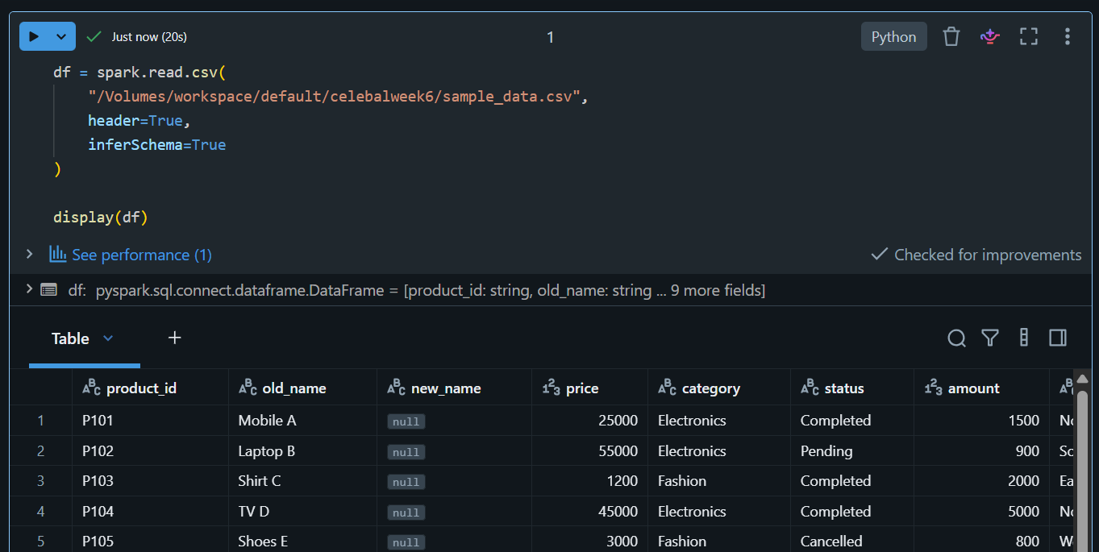
Q4: What is the difference between CSV and Parquet in terms of storage (row-based vs. columnar) and why does it matter for performance?
Feature | CSV | Parquet
Storage Type | Row-based | Columnar
Compression | Poor | Excellent
Schema | Not stored | Stored
Query Speed | Slower | Faster
Storage Size | Larger | Smaller
Why it matters
- CSV reads all columns even if only one is required.
- Parquet reads only required columns.
- Less disk I/O.
- Better compression.
- Faster analytical queries.
Therefore, Parquet is preferred for Big Data workloads.

Q5: Given a DataFrame df, write a query to select the columns product_id and price where the category is 'Electronics'.
df.filter(df.category == "Electronics") \
.select("product_id", "price")
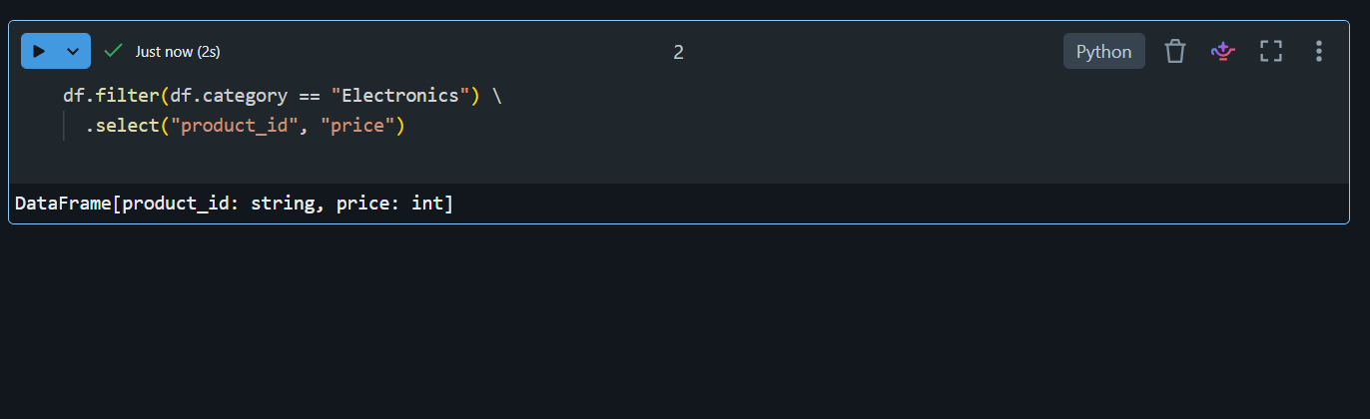

Q6: Write the code to "revise" a DataFrame by renaming the column old_name to new_name and casting the price column from a String to a Double.
from pyspark.sql.functions import col
df_new = df.withColumnRenamed("old_name", "new_name") \
.withColumn("price",
col("price").cast("double"))
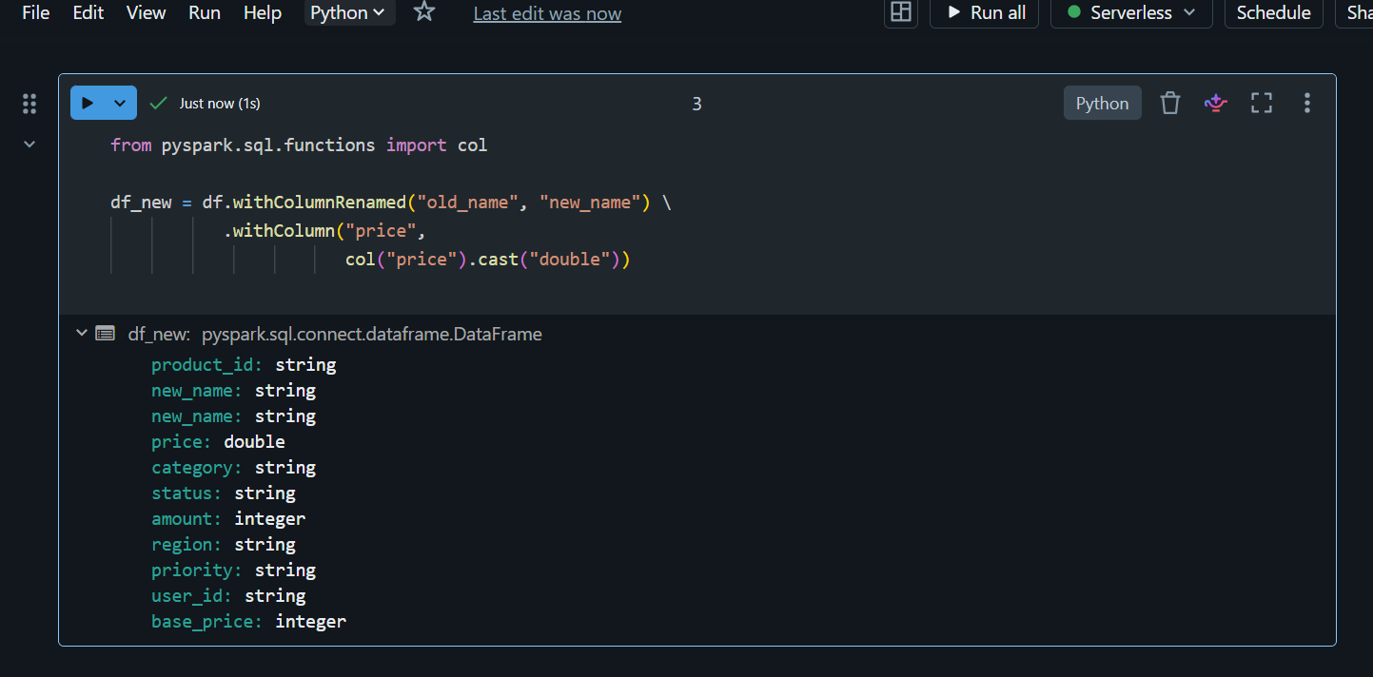
Q7: How does Spark use the Lineage Graph (DAG) to provide fault tolerance if a worker node fails?
Spark stores the sequence of transformations applied to data as a DAG (Lineage Graph).
If an executor or worker node fails:
- Spark does not need to reload all data.
- It uses the lineage information.
- Recomputes only the lost partitions.
- Continues processing automatically.
Advantages
- No data replication required.
- Efficient recovery.
- High fault tolerance.

Q8: Write a query to filter a DataFrame df_orders for rows where the status is 'Completed' AND the amount is greater than 1000.
from pyspark.sql.functions import col
df_orders.filter(
(col("status") == "Completed") &
(col("amount") > 1000)
)
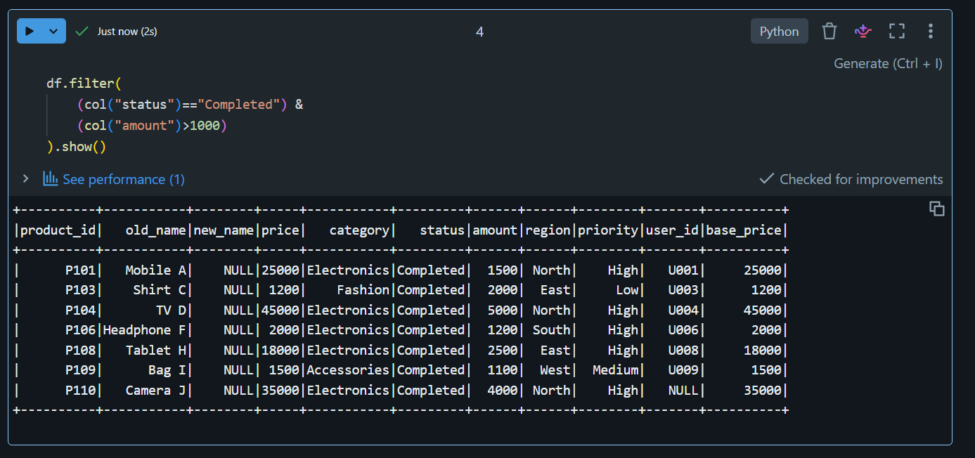
Q9: Explain the concept of Predicate Pushdown in Parquet and how it affects the amount of data loaded into memory.
Predicate Pushdown means Spark sends filter conditions directly to the Parquet reader.
Example
df.filter(col("age") > 30)
Instead of loading the entire file:
- Parquet checks metadata.
- Skips irrelevant row groups.
- Reads only matching data.
Benefits
- Less data loaded into memory.
- Faster query execution.
- Reduced CPU usage.
- Lower disk I/O.

Q10: Write a code snippet to add a new column final_price which is the base_price multiplied by 1.18 (18% tax).
from pyspark.sql.functions import col
df = df.withColumn(
"final_price",
col("base_price") * 1.18
)
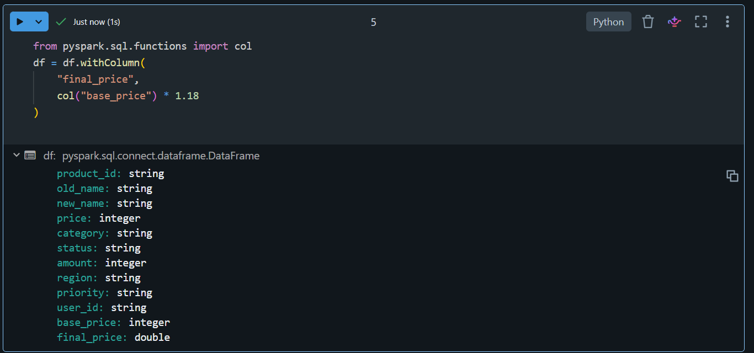
Q11: What is the difference between Transformations and Actions? Provide two examples of each.
Transformations
- Create a new DataFrame/RDD.
- Lazy in nature.
- Not executed immediately.
Actions
- Trigger execution.
- Return results or write output.

Transformation | Action

Lazy | Executes Job

Creates new DataFrame | Produces result

Builds DAG | Triggers DAG
Q12: Write the Spark command to load a Parquet file from "path/to/input", filter out any rows where user_id is null, and save the result as a CSV at "path/to/output".
from pyspark.sql.functions import col
spark.read.parquet("path/to/input") \
.filter(col("user_id").isNotNull()) \
.write \
.mode("overwrite") \
.option("header", True) \
.csv("path/to/output")
Q13: In Spark Architecture, what is the difference between Client Mode and Cluster Mode?
Feature | Client Mode | Cluster Mode
Driver Location | User Machine | Cluster Node
Driver Dependency | User machine must stay alive | Independent
Network Traffic | Higher | Lower
Suitable For | Development/Testing | Production
Client Mode
- Driver runs on local machine.
- Executors run in cluster.
Cluster Mode
- Driver and executors both run inside cluster.
- Better reliability and scalability.

Q14: Write a query to filter a dataset for rows where the region is 'North' OR the priority is 'High'.
from pyspark.sql.functions import col
df.filter(
(col("region") == "North") |
(col("priority") == "High")
)
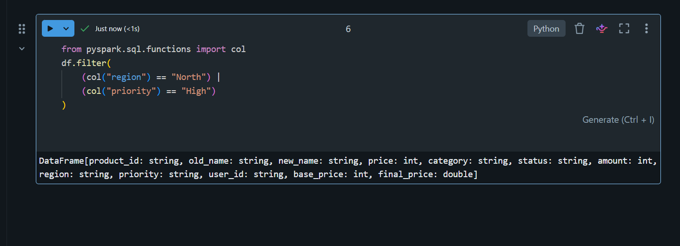
Q15: When exploring a dataset, why is it safer to use .show(5) instead of .collect() on a multi-terabyte dataset?
.show(5)
df.show(5)
- Retrieves only a few rows.
- Minimal memory usage.
- Safe for very large datasets.
- Good for data inspection.
.collect()
df.collect()
- Transfers all data to the Driver.
- Can exhaust Driver memory.
- May crash the application.
- Very expensive for large datasets.
Conclusion
For large datasets, use:
df.show(5)
instead of:
df.collect()
because it avoids loading the entire dataset into Driver memory and prevents OutOfMemory errors.

